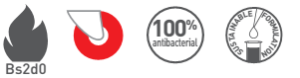

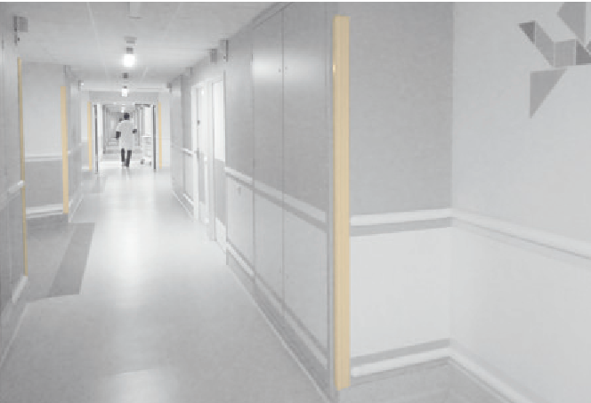

SPECIFICATION

CORNEAFLEX
135° AND VARIABLE ANGLE CORNER PROTECTOR
ON ALUMINIUM CORE

- Description: 135° or variable angle corner protector with flexible strip on aluminium core (Corneaflex as manufactured by SPM) from smooth and antibacterial PVC, 2.5 mm to 3.5 mm thick, achieving Bs2d0 fire rating with solid colour. A protective film is specified to minimise cleaning before acceptance. Wings are 65 mm wide (internal measurement), open at 135° angle or variable angle, and snap-fix onto a continuous pre-drilled aluminium core. The rounded flexible central strip forms a decorative and highly effective cushion thanks to two internal flexible PVC reinforcement beads. The 135° corner protector is finished with a smooth PVC endcap. The variable angle corner protector is installed full height (floor-to-ceiling).
- Environment: no heavy metals and no substance potentially subjected to any REACH restriction are used in its manufacture, nor PBT/BPA. The calcium-zinc thermal stabilisation process is used. The emission level of volatile substance in inside air has been tested according to ISO 16000-6 and is very low (A+) according to the French regulation (23 March 2011 nr 2011-321 Decree and 19 April 2011 Order). 100% of the product are recyclable.
- Colour: selected by architects from manufacturer’s standard range.
- Installation method: snap-fixes onto continuous pre-drilled aluminium core screwed to the wall.
